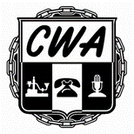

**Saturday - June 26, 2021 8 a.m. – 2 p.m.**

**Take pride in your local and help clean up, replace and repair items at hand. We will clean, remove and repair. We will have a great cookout for all members. Meet your new President. MANY HANDS MAKE LIGHT WORK**

**SAFETY IS AN ONGOING BUSINESS – WILL YOU JOIN US!!!**

**GET INVOLVE**

***LOCAL 3902***

***210 Summit Parkway Birmingham AL***

**For more information, call the hall: 205.945.1979**

**VOLUNTEERS NEEDED** 